1.Screenshot of the code execution results in Phase 1

2.Screenshot of the code execution results in Phase 2
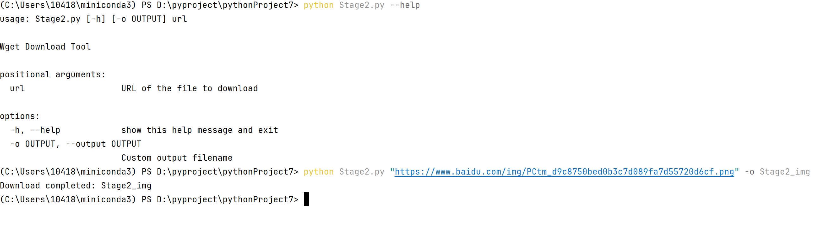

3.Screenshot of the code execution results in Phase 3
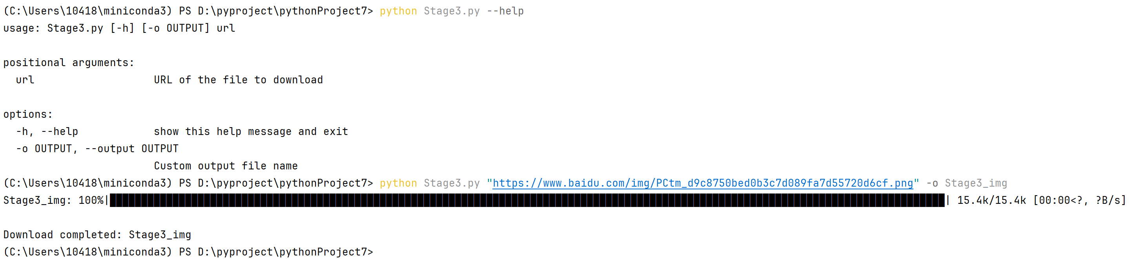

4.Screenshot of the code execution results in Phase 5

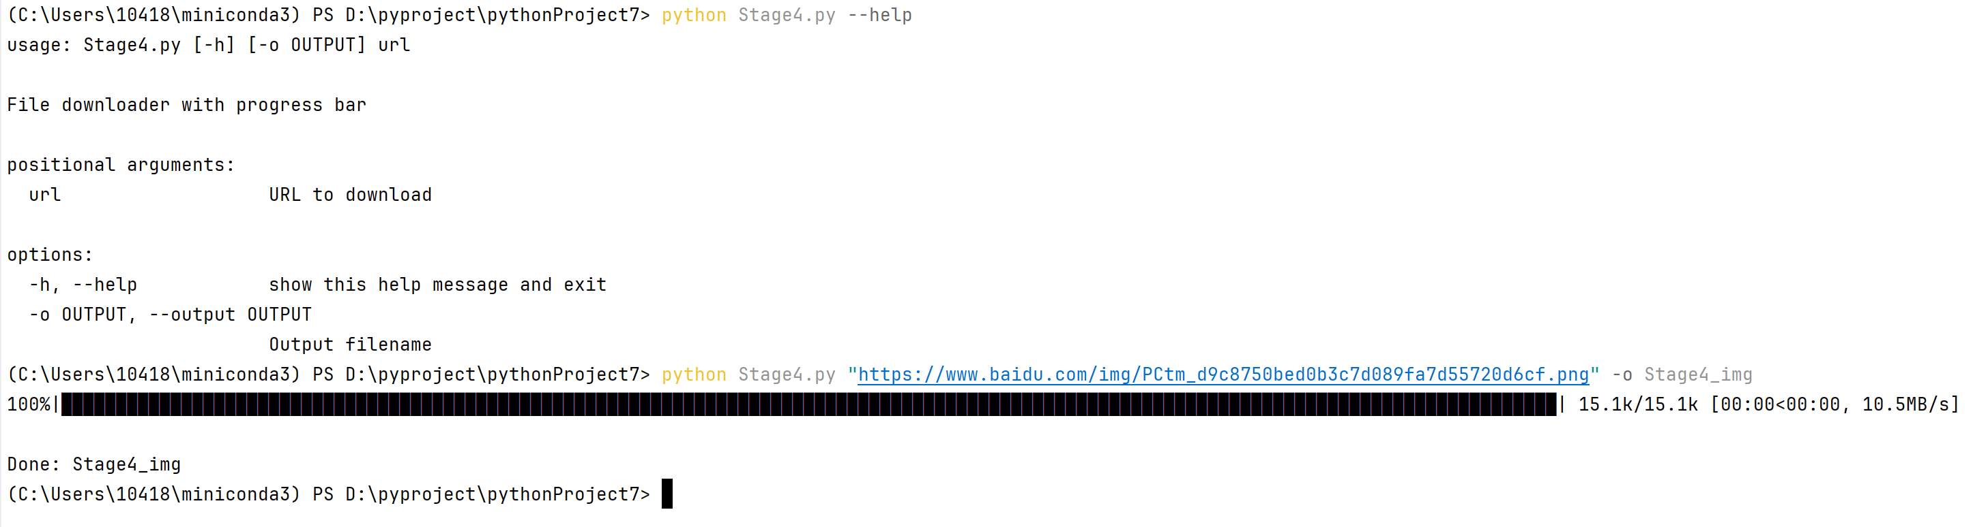

5.Screenshot of the code execution results in Phase 1
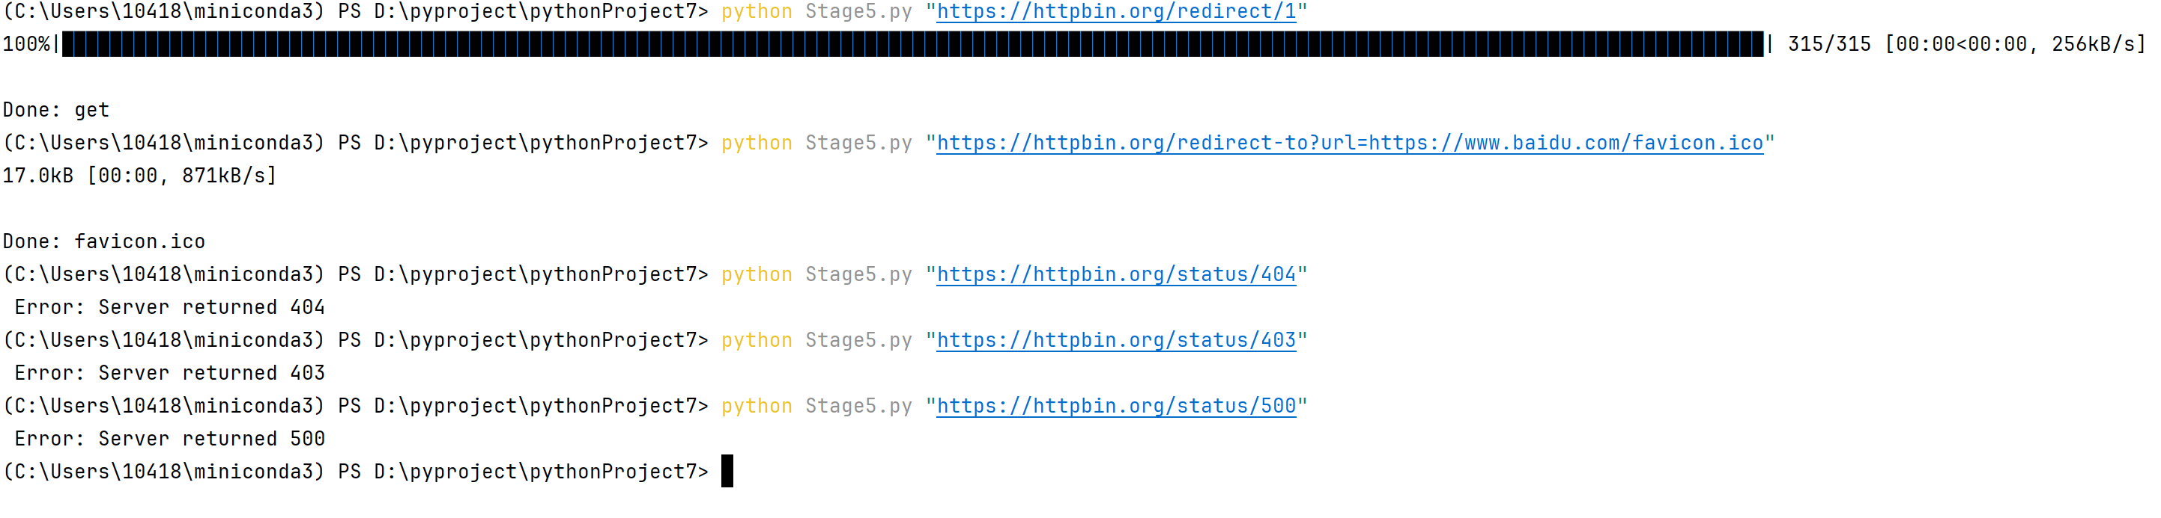
6. Screenshot of the code execution results in Phase 6
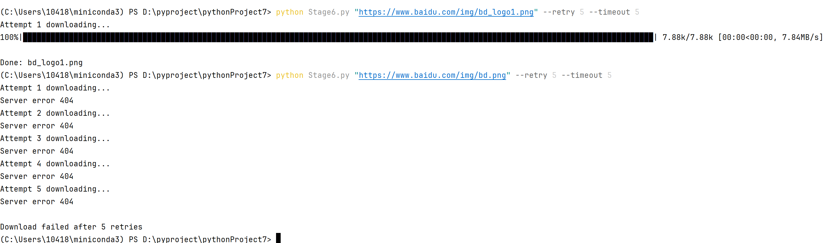
7.Screenshot of the code execution results in Phase 7
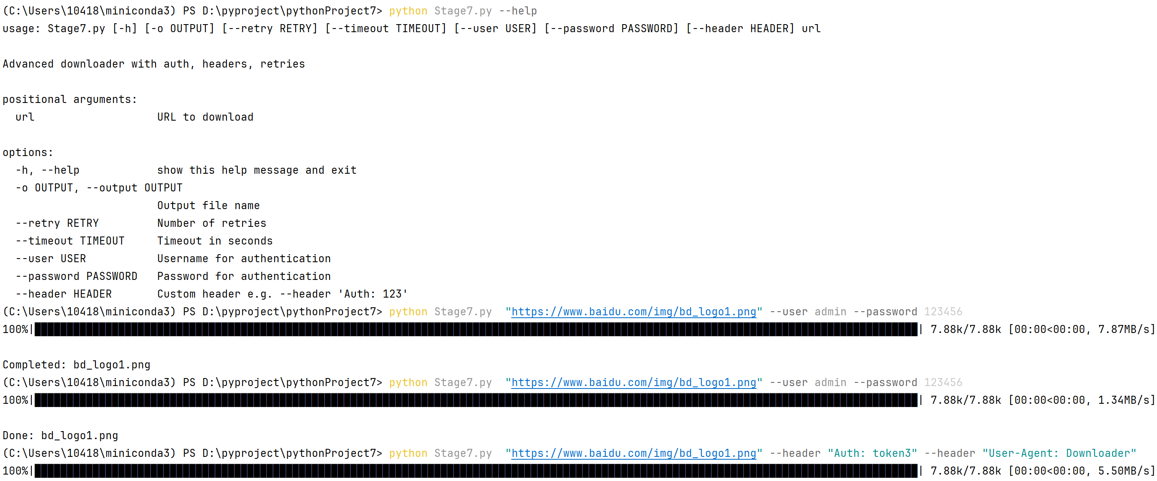

8.Screenshot of the code execution results in Phase 8
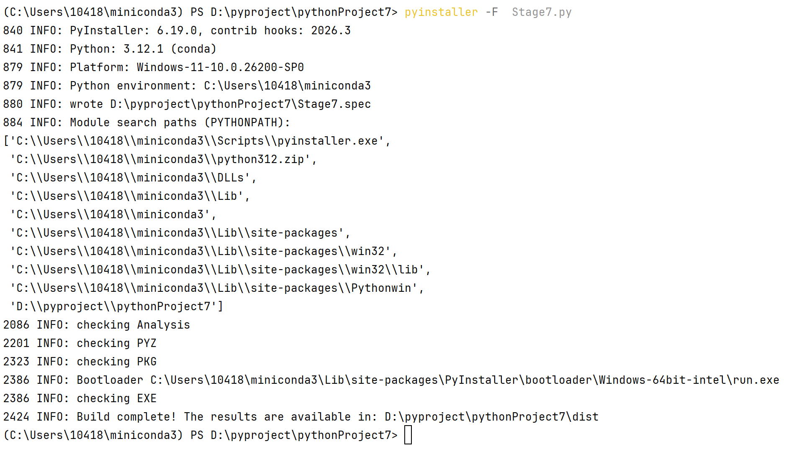
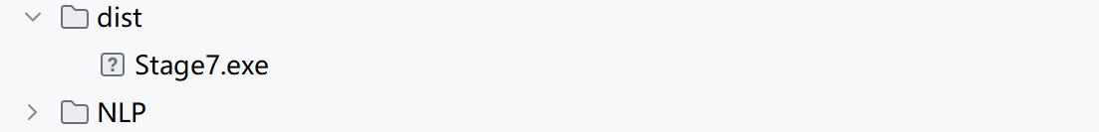

9.Screenshot of the code execution results in Phase 9
